# Generate C files with designed flaws

### Code refactoring redesign code logic

For generating c files with new designed flaws, the generate.py is the most important file. Using the method of multiway merging, refactor the main process of generating code files. The code outline is as follows:

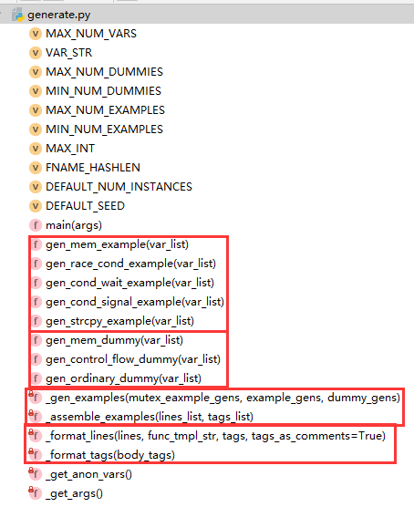

For each gen_xx_example or gen_xx_dummy function, return a list of code blocks and a coresponding list of tag blocks. The code lines in each block are inseparable.

In the main function, three generator lists are created with those gen functions – mutex_example_gens, example_gens and dummy_gens.

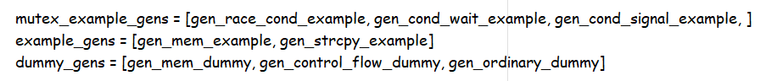

Then it calls the function gen_examples, using these generator lists to randomly generate the two lists of code blocks and tag blocks.

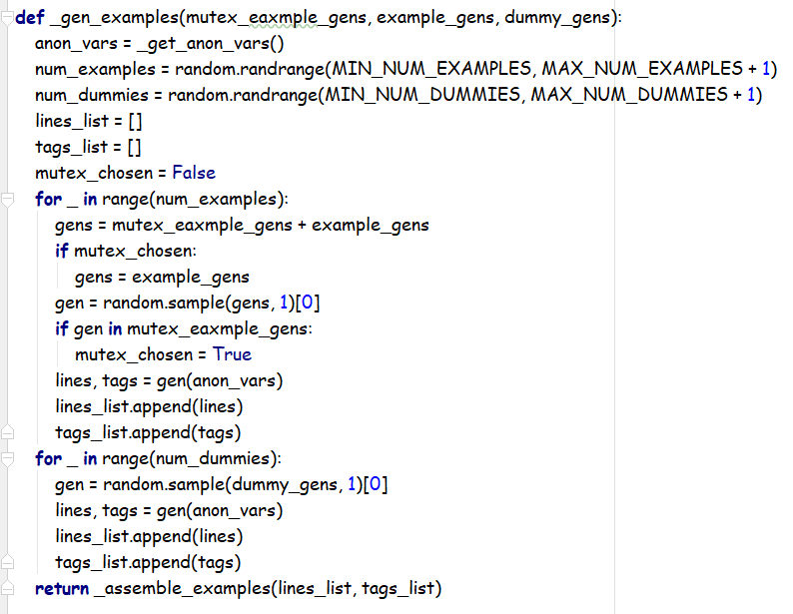

The lists are transmitted to assemble_example function in which the blocks are assembled and formatted into one c file. While assembled, the blocks are mixed logically into one block by multiway merging.

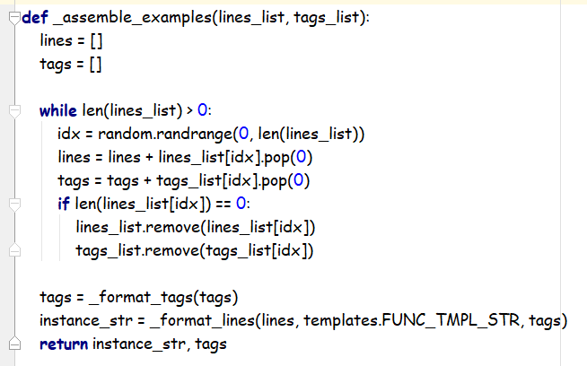

By this way, the templates of vulnerabilities and dummy statements are easy to add and modify, implementing mixed generation of multiple vulnerabilities and dummy statements as well as realizing the interpolation of multiple vulnerabilities and dummy statements on the premise of logical conformity.

### The details of each flaw template

#### Signal scheduling

Tag

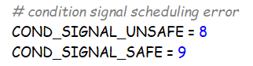

Generate function



Template

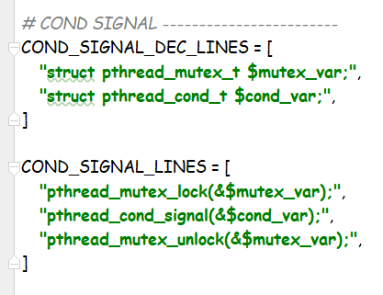

#### Conditional var wait with while-loop

Tag

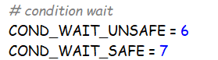

Generate function



Template

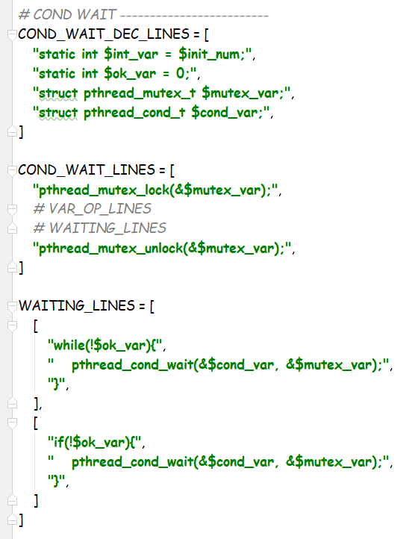

#### Mutex lock

Tag

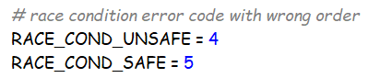

Generate function



Template

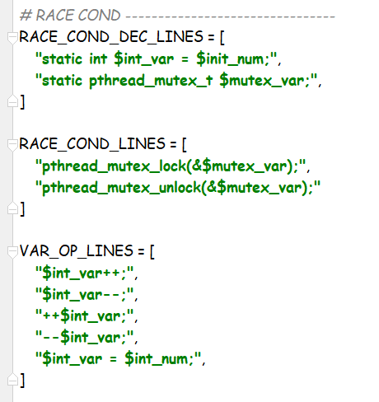

#### Malloc

Tag

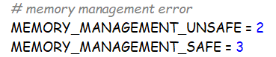

Generate function



Template

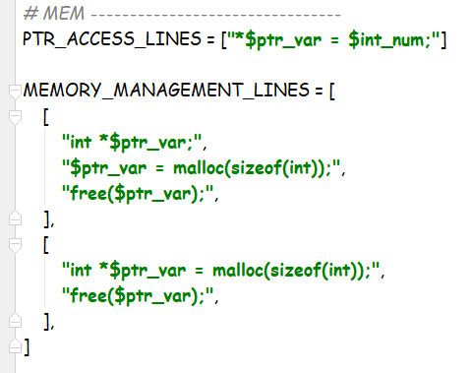

#### String copy buffer overflow

Tag

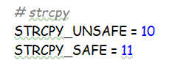

Generate function



Template

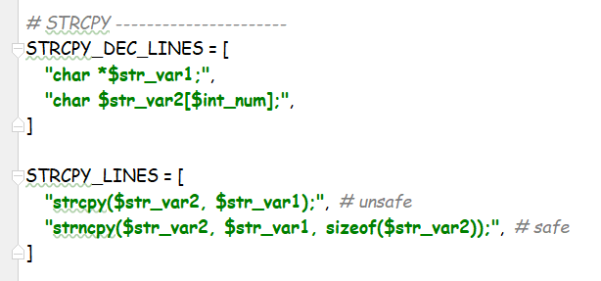

### Dummy templates

#### Control flow dummy

Generate function



Template

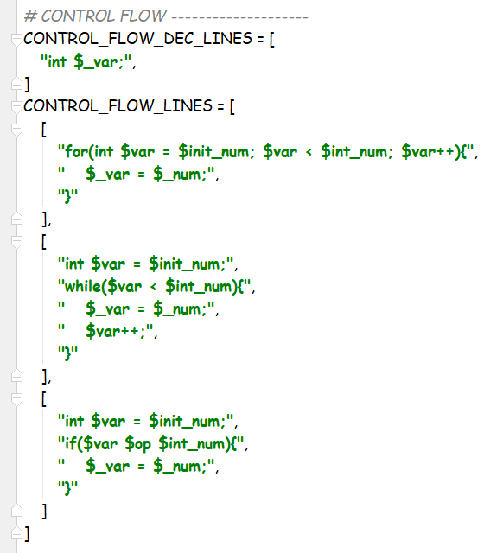

#### Ordinary dummy

Generate function



Template

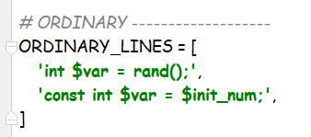

### Other

Change corresponding functions in other python files

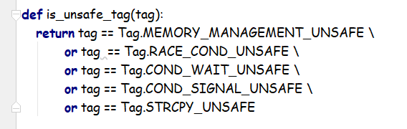

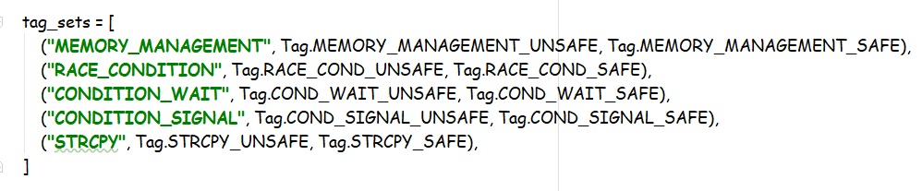

For static check tools, there are no available thread module, for which declarations and definitions are added to make it through.

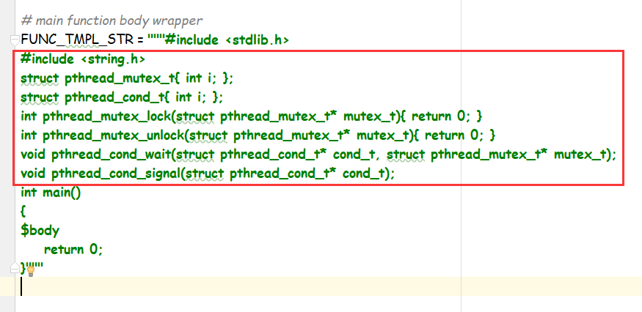

### Result example

